Part A
Name:-
Roll No:-
Subject:- Data Structures and Algorithms
Program: B Tech/MBA Tech CE 2nd Year
Aim:
To study and implement concept of Stack data structure
Prerequisite: C++ Programming
Outcome: To implement stack and its operations.
- Theory: Stack is a linear data structure which stores the elements in an ordered manner.
- The elements in a stack are added and removed only from one end which is called top.
- The policy is LIFO, the element that was inserted last is the first one to be taken out.
Operations-
- Push(element)- inserts an element at top of the stack
- Pop() – removes the topmost element
- Peek()- returns the topmost element without removing
- isEmpty() – checks if stack is empty
- isFull()- checks if stack is full

Push operation
- Step 1: IF TOP == MAX-1
  - PRINT OVERFLOW
  - Goto step 4
- [END OF IF]
- Step 2: SET TOP = TOP + 1
- Step 3: SET STACK[TOP] = VALUE
- Step 4: END
Pop operation
- Step 1: IF TOP = -1
  - PRINT UNDERFLOW
  - Go to step 4
- [END OF IF]
- Step 2: SET VAL = STACK[TOP]
- Step 3: SET TOP = TOP - 1
- Step 4: END
Peek operation
- Step 1: IF TOP = -1
  - PRINT UNDERFLOW
  - Go to step 4
- [END OF IF]
- Step 2: SET VAL = STACK[TOP]
- Step 3: SET TOP = TOP - 1
- Step 4: END

Procedure:
- Open CodeBlock editor or visual studio editor and write the code in C++.
- Complile and run the code
Instructions:
- Implement stack and operations: push, pop and peek.
- Write a program to reverse a string using stack

Copy code & paste in code section and output of Part B.

Part B
Code:
1.
#include <iostream>
using namespace std;

int top =-1;
int max = 5;
int stack[5];

void push(int &top, int stack[], int val) {
if (top>=(4))
{
cout<<"Stack Overflow";

} else {
top++;
stack[top] = val;
}

}

void pop(int &top, int stack[]) {
if (top==-1)
{
cout<<"Stack is Empty!!";
} else {
cout<<"Element " <<stack[top]<<" removed from stack";
top--;
}
cout<<endl;
}

void peek(int &top, int stack[]) {
if (top==-1)
{
cout<<"Stack is Empty!!";
} else {
cout<<"Element " <<stack[top]<<" is the top from stack";
}
cout<<endl;
}

void display(int &top, int stack[]) {
if (top==-1)
{
cout<<"Stack is Empty!!";
} else {
for(int i=0; i<=top; i++) {
cout<<stack[i]<<" ";
}
}
cout<<endl;
}

int main() {
int ch;
do
{
cout<<endl;
cout<<"1:push 2:pop 3:peek 4:display 5:Exit"<<endl;
cout<<"Enter choice: ";
cin>>ch;
switch (ch)
{
case 1:
int val;
cout<<"Enter value: ";
cin>>val;
push(top, stack, val);
break;

case 2:
pop(top, stack);
break;

case 3:
peek(top, stack);
break;

case 4:
display(top, stack);
break;

case 5:
cout<<"Exiting!!";
return 0;

default: {
break;
}
}
} while (ch!=5);

}

2.

#include <iostream>
using namespace std;

int top = 4;
char stack[5] = {'h', 'e', 'l', 'l', 'o'};
char revStack[5];

char pop(int &top, char stack[]) {
if (top == -1) {
cout << "Stack is Empty!!";
return '\0';
} else {
char letter = stack[top];
top--;
return letter;
}
}

void reverseString(int &top, char stack[], char revStack[]) {
int originalTop = top;
for (int i = 0; i <= originalTop; i++) {
revStack[i] = pop(top, stack);
}
}

int main() {
cout << "Reverse String: ";
reverseString(top, stack, revStack);

for (int i = 0; i < 5; i++) {
cout << revStack[i];
}
cout << endl;
return 0;
}

Output:
1.
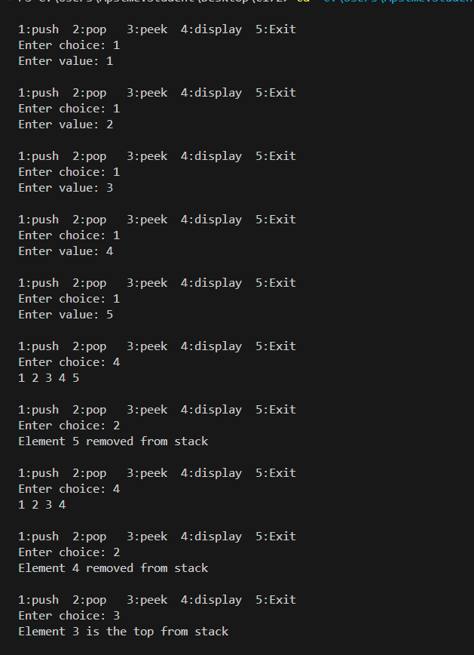

2.
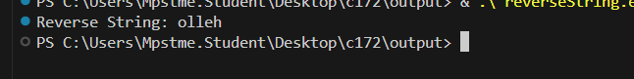
Observation & Learning:
Write your Observations & Learning after performing task
Answer Following Question
- List applications of stack data structures.
- After following operations are performed on stack, which element is at the top
Push(3), push(2), pop(), push (4), push(10), pop()

- Applications of Stack:
  - Expression evaluation (infix, postfix, prefix)
  - Function call management (call stack)
  - Undo/Redo operations in editors
  - Syntax parsing (parentheses matching)
  - Backtracking algorithms (e.g., maze solving)
  - Browser history navigation
- Stack Operations Result:
- Push(3) → Stack: [3] (top = 3)
- Push(2) → Stack: [3, 2] (top = 2)
- Pop() → Removes 2 → Stack: [3] (top = 3)
- Push(4) → Stack: [3, 4] (top = 4)
- Push(10) → Stack: [3, 4, 10] (top = 10)
- Pop() → Removes 10 → Stack: [3, 4] (top = 4)
Top element = 4

Conclusion:
We successfully implemented C++ program on arrays and its operations.
We understood stack implementation and how it also helps in reversing string

